
Anekant Education Society's
Tuljaram Chaturchand College of Arts, Science and Commerce
Baramati (Autonomous)
Department of BBA(CA)
A Project report on
“Employee Management System”
Submitted in partial fulfillment of the requirements
For the award of degree of
BBA(CA)
Submitted by

1)Mr. Tejas Shinde
Seat No: - 2486
2)Mr. Tejas Taware
Seat No: - 2484

Under the guidance of
Prof. N.H. Shaikh


Anekant Education Society’s
Tuljaram Chaturchand College of Arts, Science and Commerce
Baramati (Autonomous)
Department of Computer Application

CERTIFICATE
Seat No: - Date: -16/10/2023

This is to certify that the project entitled “Employee Management System” submitted by Mr. Tejas Rupesh Shinde and Mr. Tejas Santosh Taware in partial fulfillment of the requirements for the award of degree of BBA(CA) to Savitribai Phule University of Pune, has been carried out by them under my guidance satisfactorily during the academic year 2023-2024.

Project Guide H.O.D

Internal Examiner External Examiner

ACKNOWLEDGEMENT

We are thankful to Prof Dr A.S. Jagtap Principal of Tuljaram Chaturchand College, Baramati for making available all the required resources and co-operation in our project work.
We are thankful to Prof. Patil S.P Head of BBA(CA) Department. Tuljaram Chaturchand College, Baramati for making available all the required resources and co-operation in our project work.
It gives us great pleasure to express gratitude to Prof. Mrs. N.H. Shaikh for her valuable guidance and suggestion while preparing this project.
I wish to express my sincere thanks to BBA(CA) Department and all teaching and non-teaching staff. For their extraordinary help throughout the period of my project. We are especially thankful to those who helped us directly-indirectly in completion of this work successfully.

Date: 16/10/2023 Name: Shinde Tejas Rupesh [2486]

Place: Baramati Taware Tejas Santosh [2484]

INDEX
Sr.  No | Contents | Page.  No
1 | Project Title | 1
1.2 | Introduction | 5
1.3 | Scope of the System | 6
1.4 | Existing System | 7
1.5 | Proposed System | 8
1.6 | Software and Hardware Requirements | 9
1.7 | Modules | 10
2 | Feasibility Study | 11
3 | System Design | 12
3.1 | E-R-Diagram | 12
3.2 | Context Level Diagram | 13
3.2.1 | DFD (Level 0) | 13
3.2.2 | DFD (Level 1) | 14
3.2.3 | DFD (Level 2) | 15
3.3 | Activity Diagram | 16
3.4 | Sequence Diagram | 17
3.5 | Class Diagram | 18
3.6 | Component Diagram | 19
3.7 | Deployment Diagram | 20
3.8 | Use Case Diagram | 21
3.9 | State Diagram | 22
4 | Data Dictionary | 23
5 | Design of Inputs | 24
6 | Reports | 27
7 | Testing Report | 28
8 | Future Enhancement | 29
9 | Bibliography | 30
10 | Sample Code | 31

1.2 INTRODUCTION

- The Employee Management System is a comprehensive software solution designed to streamline and automate the processes related to managing employees within an organization. It aims to enhance efficiency, accuracy, and productivity by digitizing and centralizing employee information, HR tasks, and administrative procedures.

- The system offers a user-friendly interface accessible to HR personnel and employees, facilitating seamless collaboration and communication across the organization. The system provides a centralized employee database to store and manage comprehensive information about each employee, including personal details, employment history, skills, qualifications, and performance records. It ensures data accuracy and eliminates manual paperwork.

1.3 Scope of System

The scope of the Employee Management System includes the following key aspects:

- Employee Information Management: The system will capture and store comprehensive employee information, including personal details, contact information, employment history, skills, certifications, performance records, and other relevant data.

- Design of an HR management system to meet needs such as adding and deleting employees, viewing and printing employee data, and updating employee information. Employee data is stored in a well-designed database. An easy-to-use interface that will let user interact with the system.

1.4 Existing System

- The existing system for Employee Management typically involves manual and paper-based processes, which can be time-consuming, error-prone, and inefficient.

- Manual Data Entry: Employee information is often stored in physical files or spreadsheets, requiring manual data entry and updating.

- Limited Accessibility: Access to employee data and information is restricted to specific individuals or departments, leading to delays in retrieving necessary information and reducing collaboration across the organization.

- Security and Data Privacy Concerns: Storing employee information in physical files or scattered spreadsheets can lead to security risks and potential data breaches.

1.5 Proposed System

- Centralized Employee Database: The system will have a centralized database to store and manage employee information, including personal details, employment history, skills, qualifications, and performance records. It will ensure data integrity, reduce duplication, and enable easy access and updates.

- User-Friendly Interface: The system will have an intuitive and user-friendly interface accessible to HR personnel, managers, and employees. It will provide role-based access, allowing users to view and update relevant information while maintaining data privacy and security.

- By implementing the proposed Employee Management System, organizations will benefit from increased efficiency, improved data accuracy, streamlined processes, enhanced communication, and better employee engagement.

1.6 Software and Hardware Requirements

Software Requirements -
- Operating System: WINDOWS OS (Windows 7, 8,10,11) Or Linux
- Frontend: Java, Swing [Java Foundation Classes] [JFC] library and an extension of the Abstract Window Toolkit [AWT].
- Backend: MySQL, JDBC
- [For Database Connectivity].
- Integrated Development Environment (IDE): for Java development include Eclipse, IntelliJ IDEA, and NetBeans.

Hardware Requirements -
- Processor: Intel I3 2.8 GHz Processor and Above
- RAM 4 GB and Above
- Operative Memory required for the software MB
- 500 MB of free disk space for Eclipse installation
- Additional disk space for your projects and any additional plugins or extensions

1.7 Modules

Functional Admin panel:
- Allows admins to manage the whole system.
- CRUD functionalities: Allows admin to create, read, update and delete their employees’ details in a managed format.
- Profile update option: Allows admin to update employee profile/account details.
- Secure registration and login option for admin.
- Allows admin to search, update, print, view their employees’ details easily.

2. Feasibility Study

In order to do a feasibility study, we must consider the following:
- Technical Feasibility The availability of hardware & Software necessary for the creation of the system, as-well-as the compatibility and maturity of the technology planned to be used, and the availability of the requisite technical staff to create the system, are all factors to consider.
- Operational Feasibility Problems that may develop during operations are the focus of operation feasibility. There are two parts to this problem to consider:
• What are the chances that the solution provided will not be used or will
not work?
• What is the inclination of-the management and end users towards
the solution?
- Economic Feasibility The concept of economic feasibility is determining whether or not the potential benefit of fixing difficulties is worthwhile. Because member needs &alternative solutions haven’t been specified at this point, it is difficult to estimate the cost at this level.

3.System Design

3.1 E-R-Diagram

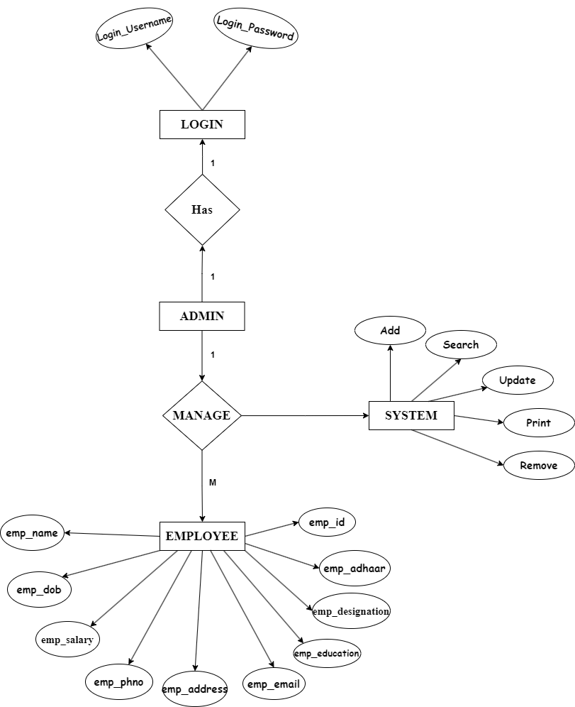
3.2 Context Level Diagram

3.2.1 DFD (Level 0)
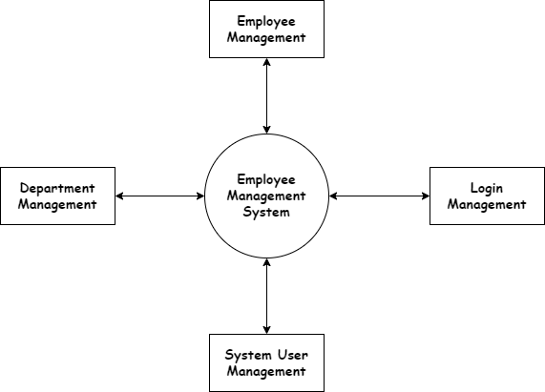

3.2.2 DFD (Level 1)

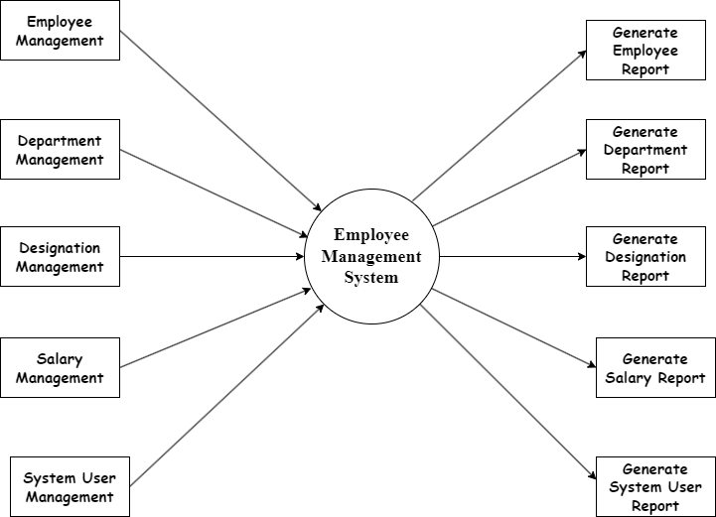

3.2.3 DFD (Level 2)
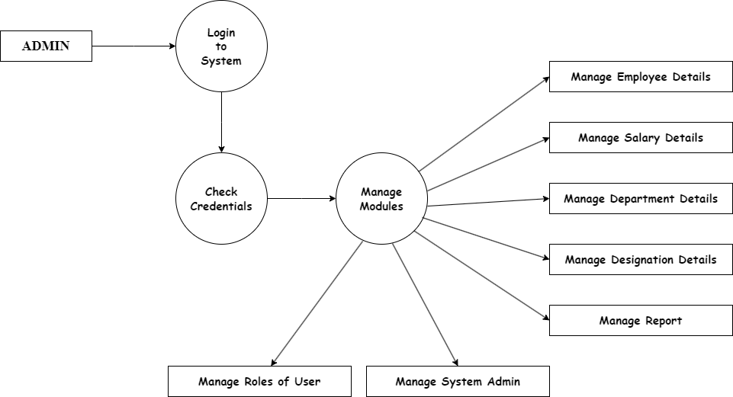

3.3 Activity Diagram

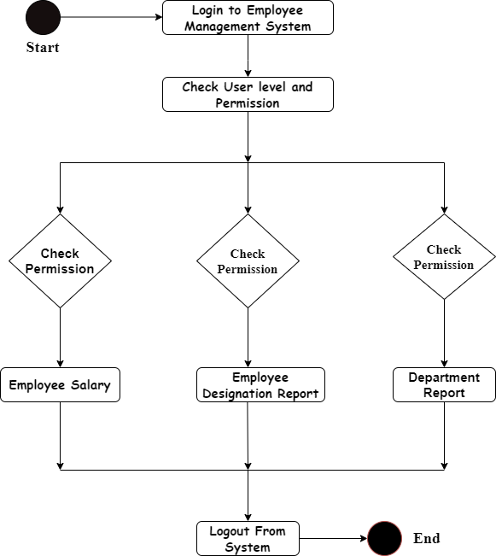

3.4 Sequence Diagram

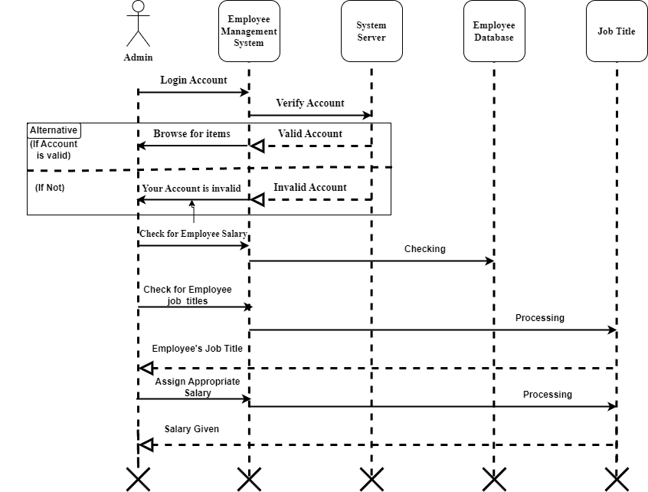

3.5 Class Diagram

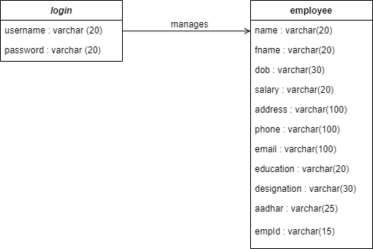

3.6 Component Diagram

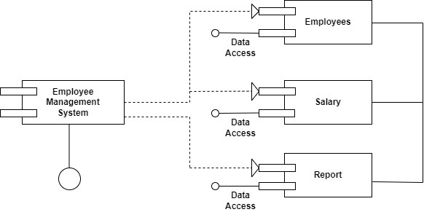

3.7 Deployment Diagram

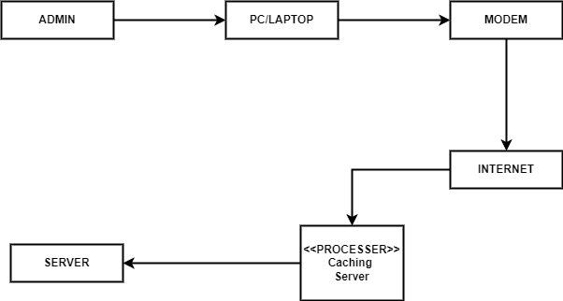

3.8 Use Case Diagram

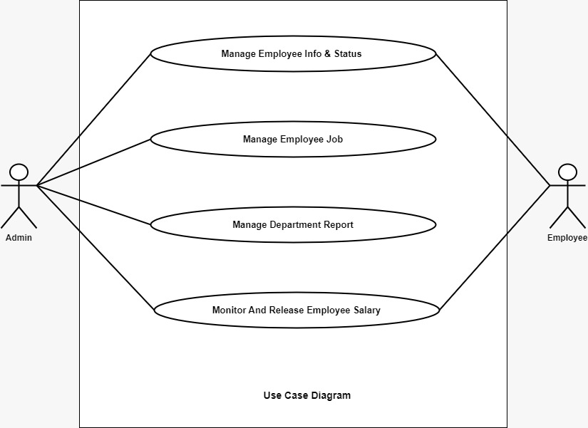

3.9 State Diagram

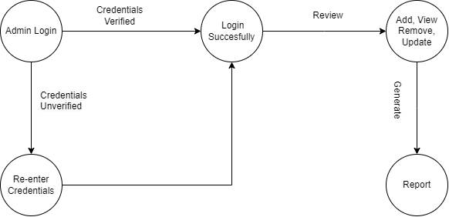

4.Data Dictionary
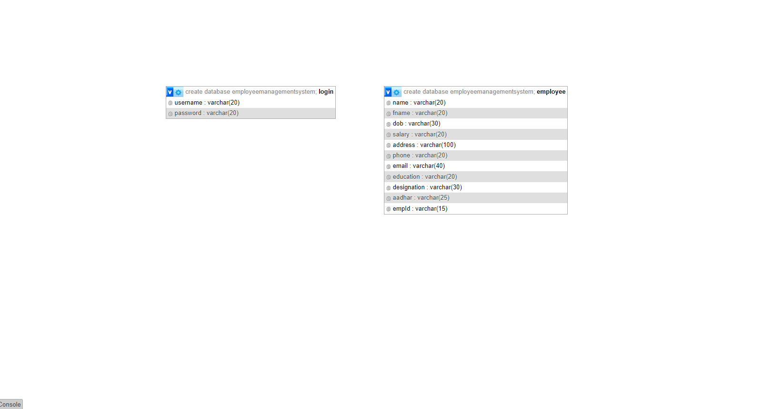

5. Design of Inputs
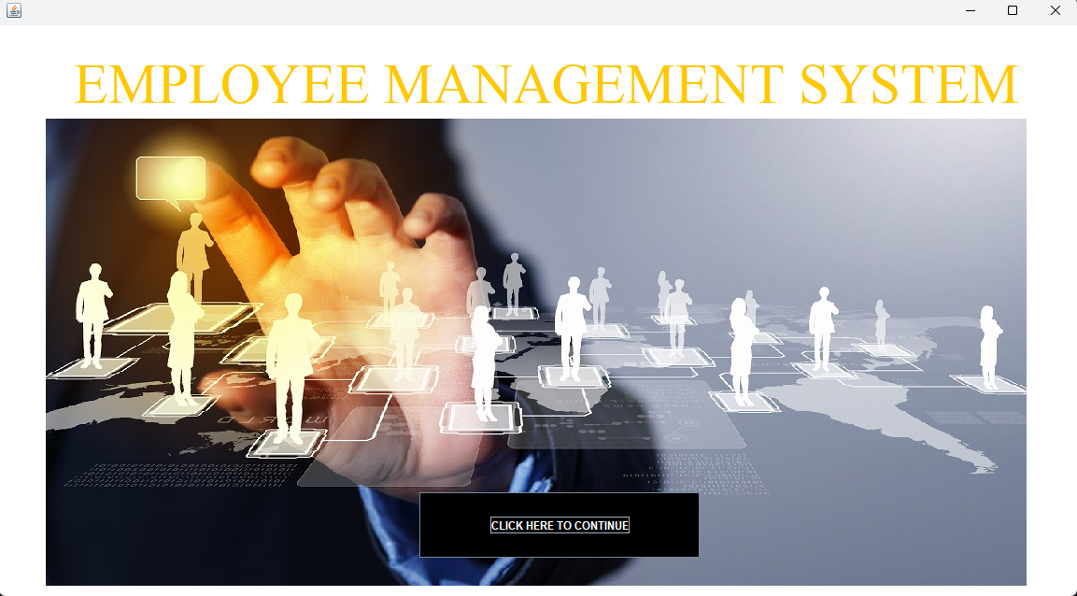

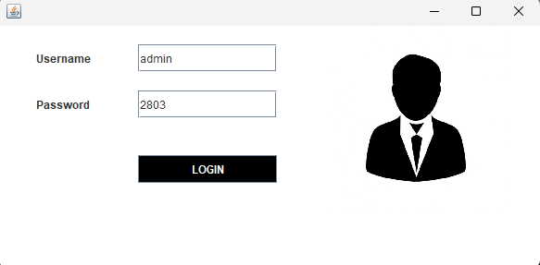

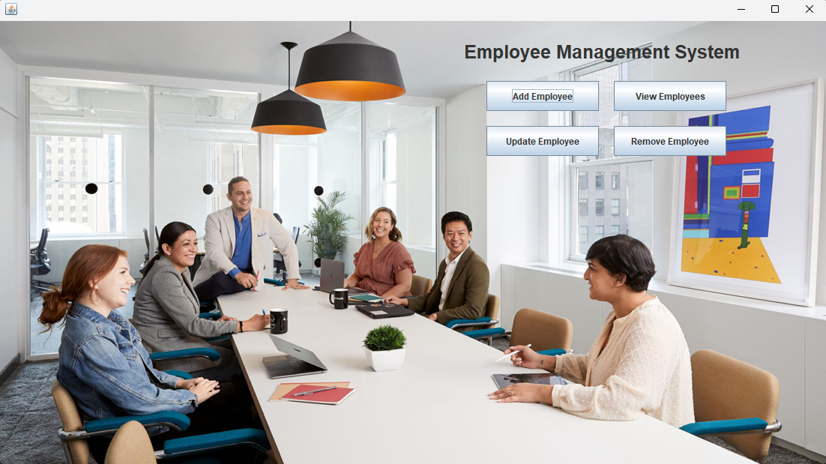

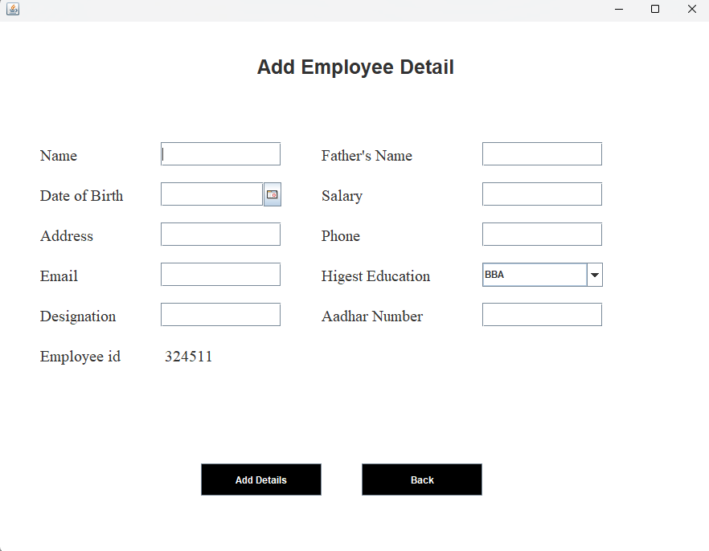
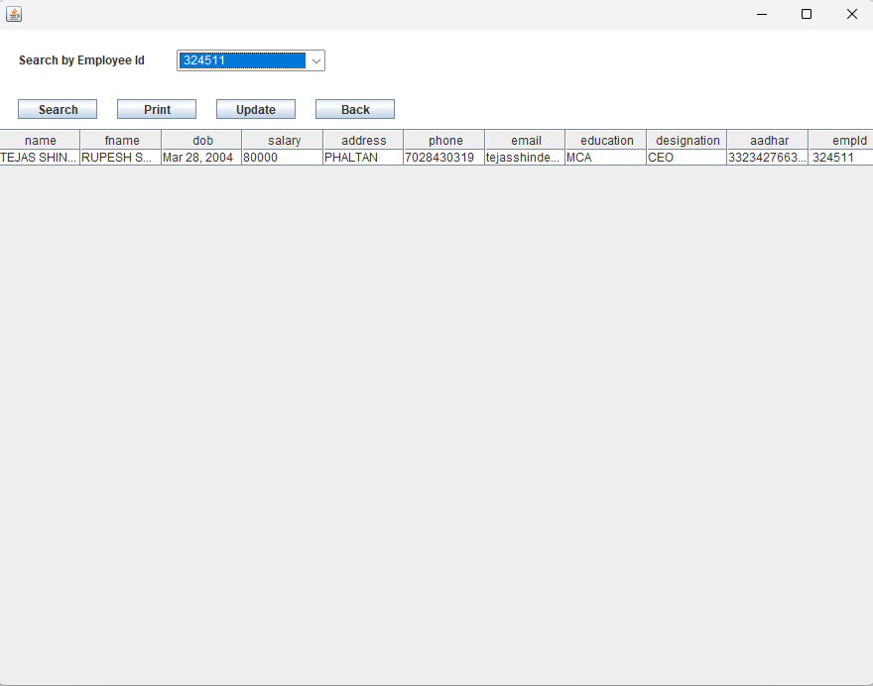
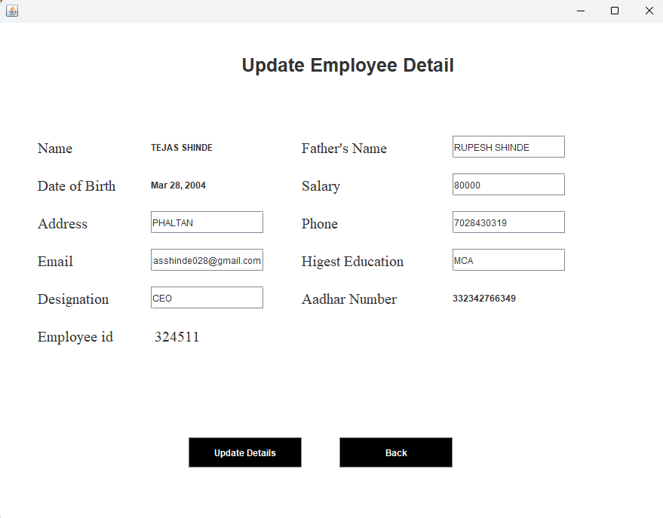
6. Reports

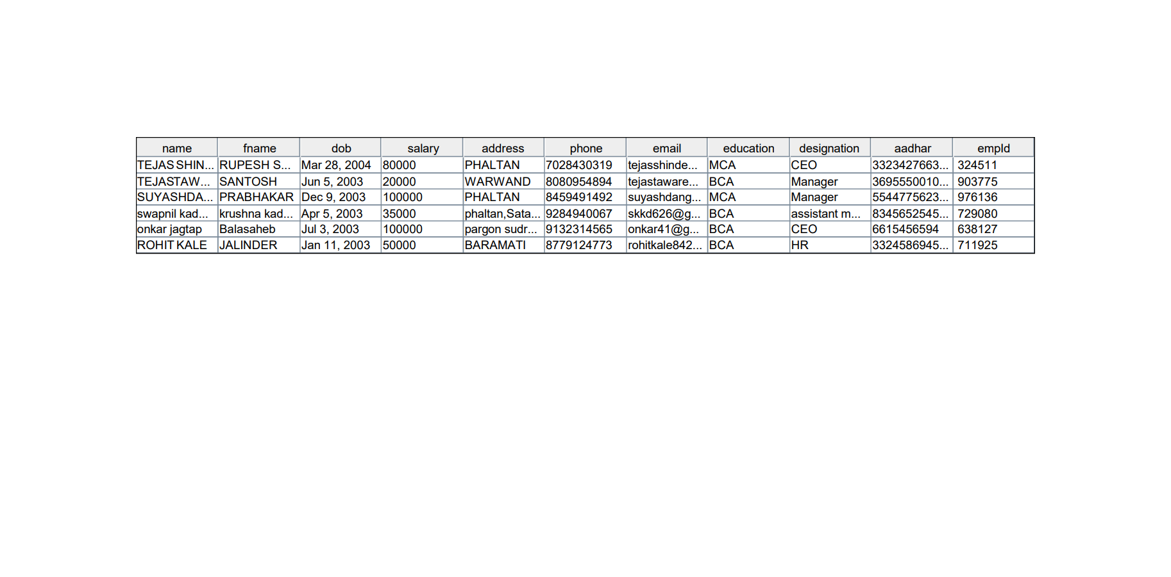

7. Testing Report

Test ID | Test-Purpose | Test-Condition | Expected-Output | Output | Remark
TC1 | Check  Username  & Password | If user details are not correct, display error message | Grant access to main dashboard. | Access  granted to  main  dashboard | Test successful
TC2 | To add new user to the system | If user already exists, error message should be displayed. | New user should be added. | New user  added  successfully | Test successful
TC3 | To view existing employee information | If employee exists, then information should be displayed, else error message should be displayed. | Employee information should be displayed. | Employee information displayed | Test successful
TC4 | To remove an employee | If employee exists, then employee should be removed else error message should be displayed. | Employee should be removed | Employee  removed  successfully. | Test successful
TC5 | Update employee information | If employee exists, then information should be updated. | Employee information should be updated. | Employee information updated successfully | Test successful

8. Future Enhancement

- The GUI and the features added to this system are the basic ones. In future, there will be a better Graphical User Interface and there will be more features added to this system.
- If Graphical User Interface is improved, then this system will be more user friendly and more features added will make this system a lot better and HR will be able to perform more operations.

9.Bibliography

1) Renae Broderick, John W. Boudreau, “Human resource management, information
technology, and the competitive edge”, Academy of Management Executive, 1992
Vol. 6 No. 2
2) Julie Bulmash, “Human Resource Management and Technology”, Chapter 3.
3) Ian Sommerville, “Software Engineering”, 9
th Edition, Addison-Wesley, 2011.
4) Avison, D. and Fitzgerald, G. (2003). Information systems Development
Methodologies, Techniques and Tools.3rd Edition. McGraw-Hill Education
Limited Bershire
5) Juan Manuel Munoz Palacio, Information systems development methodologies for Data-driven Decision Support Systems, 2010.
6) Deitel, PJ & Deitel, HM, 2008, Internet & World Wide Web How To
Program,Dorling Kindersley, India.

10. Sample Code

Home.java
package employee.management.system;
import javax.swing.*;
import java.awt.*;
import java.awt.event.*;
public class Home extends JFrame implements ActionListener{
JButton view, add, update, remove;
Home() {
setLayout(null);
ImageIcon i1 = new ImageIcon(ClassLoader.getSystemResource("icons/home.jpg"));
Image i2 = i1.getImage().getScaledInstance(1120, 630, Image.SCALE_DEFAULT);
ImageIcon i3 = new ImageIcon(i2);
JLabel image = new JLabel(i3);
image.setBounds(0, 0, 1120, 630);
add(image);

JLabel heading = new JLabel("Employee Management System");
heading.setBounds(620, 20, 400, 40);
heading.setFont(new Font("Raleway", Font.BOLD, 25));
image.add(heading);

add = new JButton("Add Employee");
add.setBounds(650, 80, 150, 40);
add.addActionListener(this);
image.add(add);

view = new JButton("View Employees");
view.setBounds(820, 80, 150, 40);
view.addActionListener(this);
image.add(view);

update = new JButton("Update Employee");
update.setBounds(650, 140, 150, 40);
update.addActionListener(this);
image.add(update);

remove = new JButton("Remove Employee");
remove.setBounds(820, 140, 150, 40);
remove.addActionListener(this);
image.add(remove);

setSize(1120, 630);
setLocation(250, 100);
setVisible(true);
}

public void actionPerformed(ActionEvent ae) {
if (ae.getSource() == add) {
setVisible(false);
new AddEmployee();
} else if (ae.getSource() == view) {
setVisible(false);
new ViewEmployee();
} else if (ae.getSource() == update) {
setVisible(false);
new ViewEmployee();
} else {
setVisible(false);
new RemoveEmployee();
}
}

public static void main(String[] args) {
new Home();
}
}

